**_Data Source**

* Discogem
* ~~qadc~~

**_Data Structure**

* The data contains 27 columns (at **leaves level**)
* Around 6500 rows
* They could be grouped into 16 columns (at **level 2**)
* ~~And also could be grouped into 4 columns (at level 1)~~

**_Data Values**

**[ LEAVES LEVEL ]**

* The data has values between 0 and 1 with **a step of 0.1**
* However, the majority of the cells are of **value 0**

|  |  |  |  |
| --- | --- | --- | --- |
| **= 0** | = 0.1 | = 0.2 | >= 0.3 |
| **85%** | 7% | 3% | 5% |

* Column wise; only 12 with 10% or more of their values are non-zero

|  |  |  |  |  |  |  |  |  |  |  |  |  |  |
| --- | --- | --- | --- | --- | --- | --- | --- | --- | --- | --- | --- | --- | --- |
|  | synchronous | precedence | reason | result | arg1-as-denier | arg2-as-denier | contrast | | similarity | conjunction | arg2-as-instance | arg1-as-detail | arg2-as-detail |
| Non-zero value% per col - % of >0 i.e. | 10% | 29% | 29% | 67% | 17% | 28% | 18% | | 12% | 76% | 30% | 18% | 60% |
| % of >0.1 per col | 3% | 15% | 13% | 46% | 5% | 12% | 6% | | 3% | 53% | 12% | 4% | 37% |
| % of >0.2 per col | 1% | 9% | 7% | 32% | 2% | 5% | 3% | | 1% | 35% | 6% | 1% | 22% |
| **Col total val/ data total val** | 1% | 7% | 6% | 22% | 3% | 6% | 3% | | 2% | 23% | 6% | 2% | 16% |
| constitute 97% of total value | | | | | |

**[ LEVEL TWO ]**

* A little better, butthe majority of the cells are of **value 0**

|  |  |  |  |  |
| --- | --- | --- | --- | --- |
| **= 0** | = 0.1 | = 0.2 | = 0.3 | >= 0,4 |
| **78%** | 9% | 5% | 3% | 5% |

* Column wise; only **6** columns contain **6%** to **28%** of the total value of the data (Rest are less than **3%**)

|  |  |  |  |  |  |  |  |  |  |  |
| --- | --- | --- | --- | --- | --- | --- | --- | --- | --- | --- |
|  | synchronous | asynchronous | cause | concession | contrast | | similarity | conjunction | instantiation | level-of-detail |
| Non-zero value% per col - % of >0 i.e. | 10% | 32% | 77% | 37% | 18% | | 12% | 76% | 31% | 67% |
| % of >0.1 per col | 3% | 16% | 59% | 17% | 6% | | 3% | 53% | 13% | 43% |
| % of >0.2 per col | 1% | 10% | 44% | 9% | 3% | | 1% | 35% | 6% | 26% |
| Col total val/ data total val | 1% | 8% | 28% | 8% | 3% | | 2% | 23% | 6% | 18% |
| constitute 97% of total value | | | | |

**_Data Visualization**

**[ LEAVES LEVEL ]** (sample)

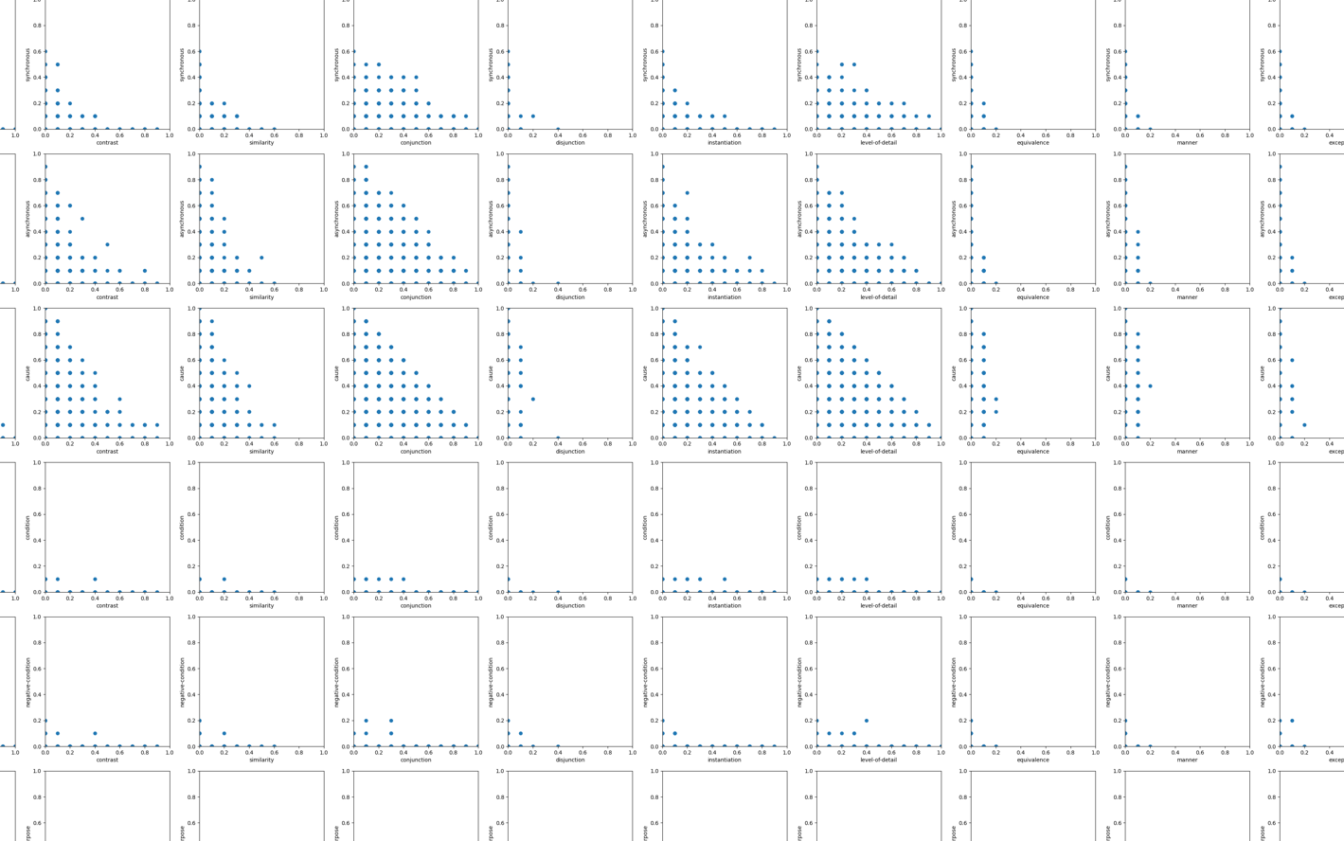

**[ LEVEL TWO ]**

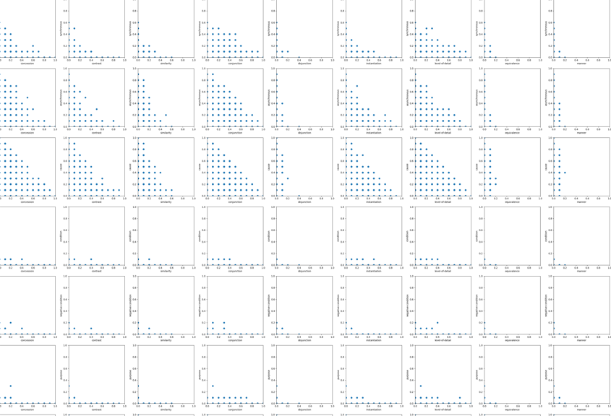

_Transform to Binary

Different threshold values used to transform the data into binary data (1 or 0). The threshold vector is

exist_thresholds = [0.1, 0.2, 0.3, 0.4]

Methods used to calculate the correlation

* Phi Coefficient (φ): [It's suitable for measuring the degree of association between two binary variables.]
* Others could be used:
  + Cramér's V: more commonly used for categorical data. Q can I use it since binary is a special case of categorical
  + Kendall's: can I use it [Suitable for both **continuous and ordinal** (ranked) data] Maybe I transfer the data into three ransl A for [0, 0.1], B for ]0.1, 02] and C for ]0.3, 1]

Phi Coefficient (φ)

_Questions

1. Is the data **compositional data**?
   1. Originally each row sums up 1
   2. We removed the last two columns for a reason and not not all the rows sum up to 1
      1. Discogem:

|  |  |
| --- | --- |
| **# of entities** (out of 6505) | **Sum of the row** |
| 3,871 (60%) | = 1 |
| 1,547 (24%) | = 0.9 |
| 1,087 (16%) | <= 0.8 |

* + 1. Quadc

|  |  |
| --- | --- |
| **# of entities** (out of 900) | **Sum of the row** |
| 830 (92%) | = 1 |
| 26 (3%) | = 0.9 |
| 44 (5%) | <= 0.8 |

Note: the sum of all the columns in each row adds up to 1 (or 0.9, 0.8 ..), and we are trying to find the correlation between a pair of columns at a time

1. If transformation is needed, are any of the three below suitable for the transformation?
   1. Additive logratio transform
   2. Isometric logratio transform
   3. Center log ratio transform
2. After transformation, what is the best correlation coefficient to use

['pearson', 'spearman', 'kendall']

|  |  |
| --- | --- |
| 'pearson' | * Assumption: Assumes a **linear relationship** and that data is normally distributed. * Use Case: Suitable for continuous data when you want to **measure linear associations.**   *[A* ***linear relationship*** *is a specific type of monotonic relationship where the* ***rate of increase*** *or decrease between two variables is* ***constant****]* |
| 'spearman' | * Assumption: **Non-parametric** and does not assume a linear relationship but assumes a **monotonic** relationship. * Use Case: Appropriate for both **continuous and ordinal data**. Particularly useful when the relationship is expected to be monotonic but not necessarily linear.   [ *A monotonic relationship, either* ***consistently increases or decreases*** *but* ***not necessarily*** *at* ***a constant rate***  ***[***Non-parametric Non-parametric, *do not make assumptions about the underlying distribution of the data.* |
| 'kendall' | * Assumption: **Non-parametric** and makes no assumptions about the data distribution. * Use Case: Suitable for both **continuous and ordinal** (ranked) data. Useful when the data may not follow a linear relationship. |

[source](Assumption:%20Non-parametric%20and%20makes%20no%20assumptions%20about%20the%20data%20distribution.%20Use%20Case:%20Suitable%20for%20both%20continuous%20and%20ordinal%20(ranked)%20data.%20Useful%20when%20the%20data%20may%20not%20follow%20a%20linear%20relationship.)

1. It is safe to say that our data are not liner? Examples

Plot the data

A quick understanding of pearson and what not

Check if they are normal distributes

Then go to the bindar